TASK OF ORACLE

CREATE TABLE Department (
dept_id INT PRIMARY KEY,
dept_name VARCHAR(50)
);

CREATE TABLE Employee (
emp_id INT PRIMARY KEY,
emp_name VARCHAR(50),
salary DECIMAL(10,2),
hire_date DATE,
dept_id INT,
FOREIGN KEY (dept_id) REFERENCES Department(dept_id)
);

Output:-

Table DEPARTMENT created.

Elapsed: 00:00:00.022

Table EMPLOYEE created.

Elapsed: 00:00:00.026

Commit complete.

Elapsed: 00:00:00.001

INSERT ALL
INTO Department VALUES (1,'HR')
INTO Department VALUES (2,'IT')
INTO Department VALUES (3,'Finance')
SELECT * FROM dual;

Output:=

Table DEPARTMENT created.

Elapsed: 00:00:00.022

INSERT ALL
INTO Employee VALUES (101,'Amit',50000,DATE '2025-01-15',1)
INTO Employee VALUES (102,'Rahul',70000,DATE '2024-12-10',2)
INTO Employee VALUES (103,'Sneha',90000,DATE '2025-03-20',2)
INTO Employee VALUES (104,'Pooja',60000,DATE '2024-08-15',1)
INTO Employee VALUES (105,'Karan',80000,DATE '2025-05-01',3)
INTO Employee VALUES (106,'Riya',70000,DATE '2025-04-10',3)
INTO Employee VALUES (107,'Vijay',90000,DATE '2025-02-15',2)
SELECT * FROM dual;

Output=>

7 rows inserted.

Elapsed: 00:00:00.011

select department.DEPT_Name,DEPARTMENT.DEPT_ID,count(emp_name)as dept_count from DEPARTMENT
join EMPLOYEE
on Department.dept_id=EMPLOYEE.dept_id
group by department.DEPARTMENT.DEPT_NAME;

output=>>
DEPT_NAME DEPT_COUNT
--------- ----------
HR 2
IT 3
Finance 2

Elapsed: 00:00:00.002
3 rows selected.

select * from EMPLOYEE
order by salary desc
where rownum<=5;
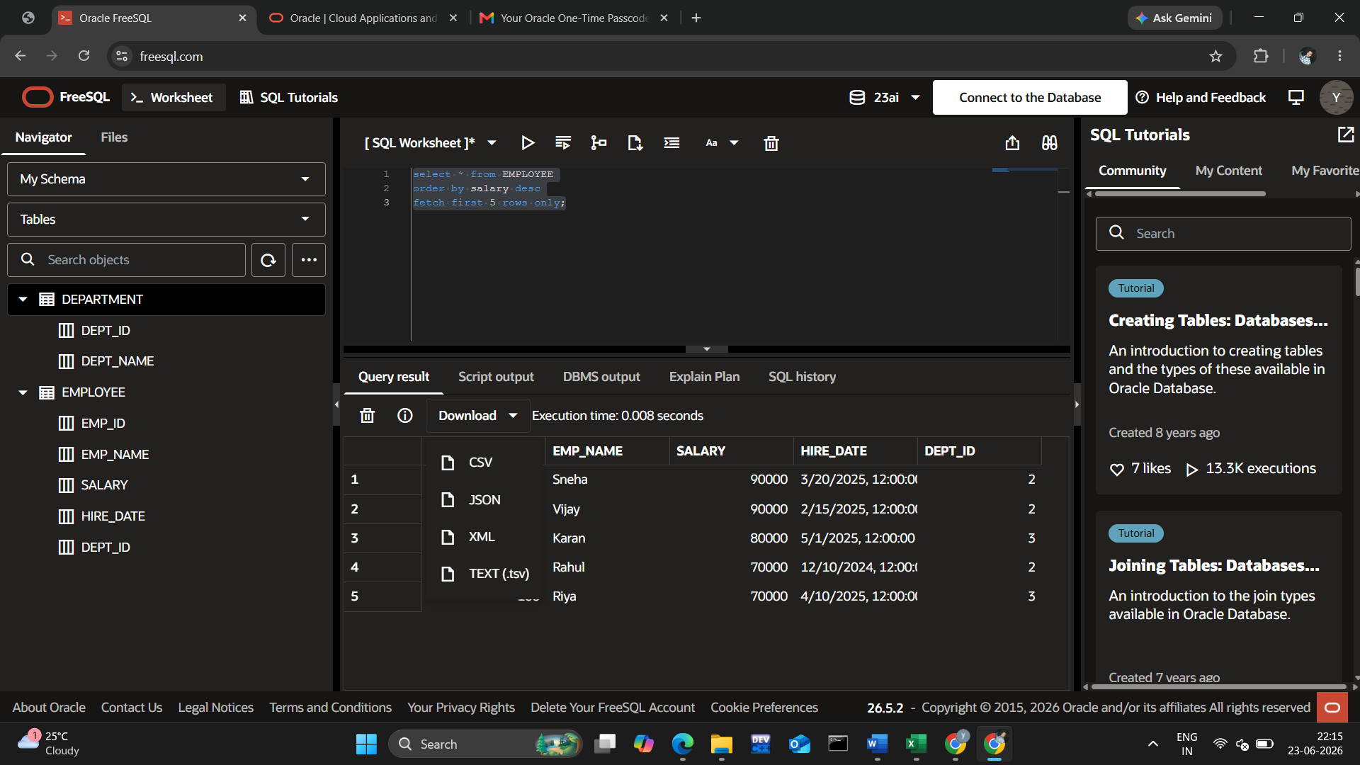

SELECT *
FROM Employee e
WHERE e.salary >
(
SELECT AVG(salary)
FROM Employee
WHERE dept_id = e.dept_id
);

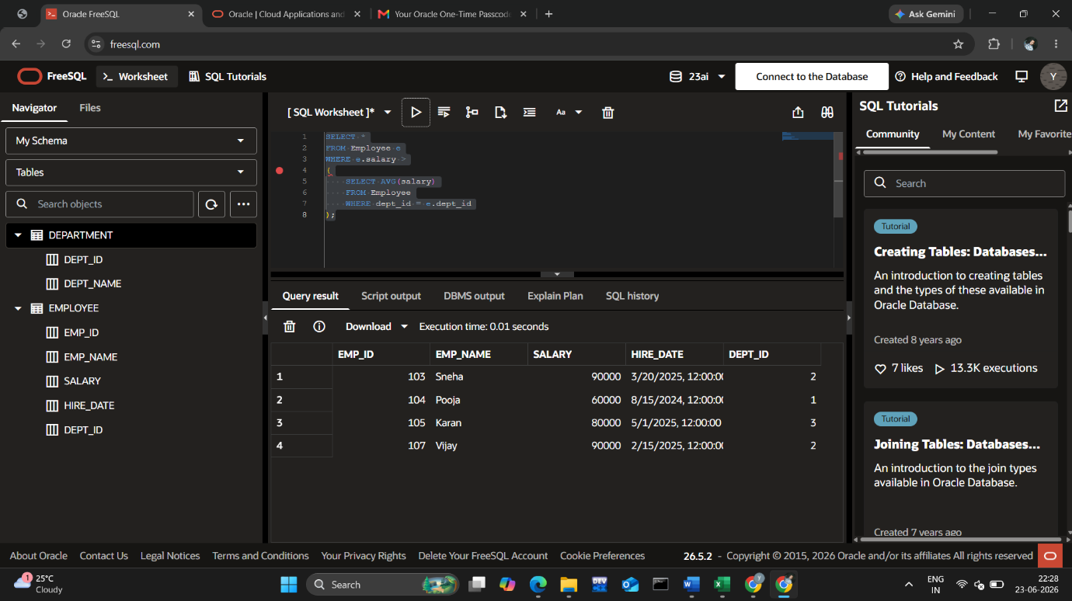

Inner Join

SELECT e.emp_name,
d.dept_name
FROM Employee e
INNER JOIN Department d
ON e.dept_id = d.dept_id;
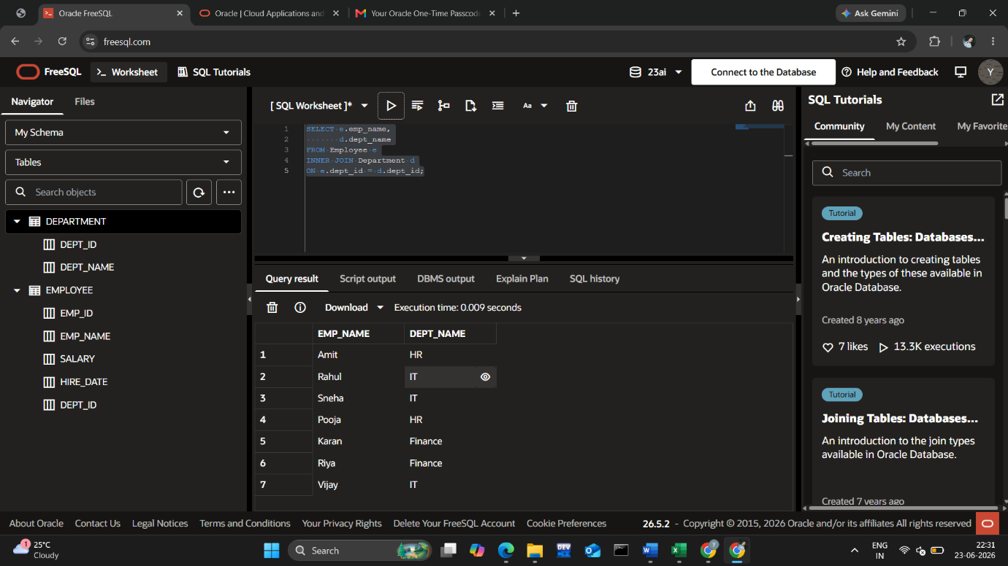

SELECT e.emp_name,
d.dept_name
FROM Employee e
LEFT JOIN Department d
ON e.dept_id = d.dept_id;

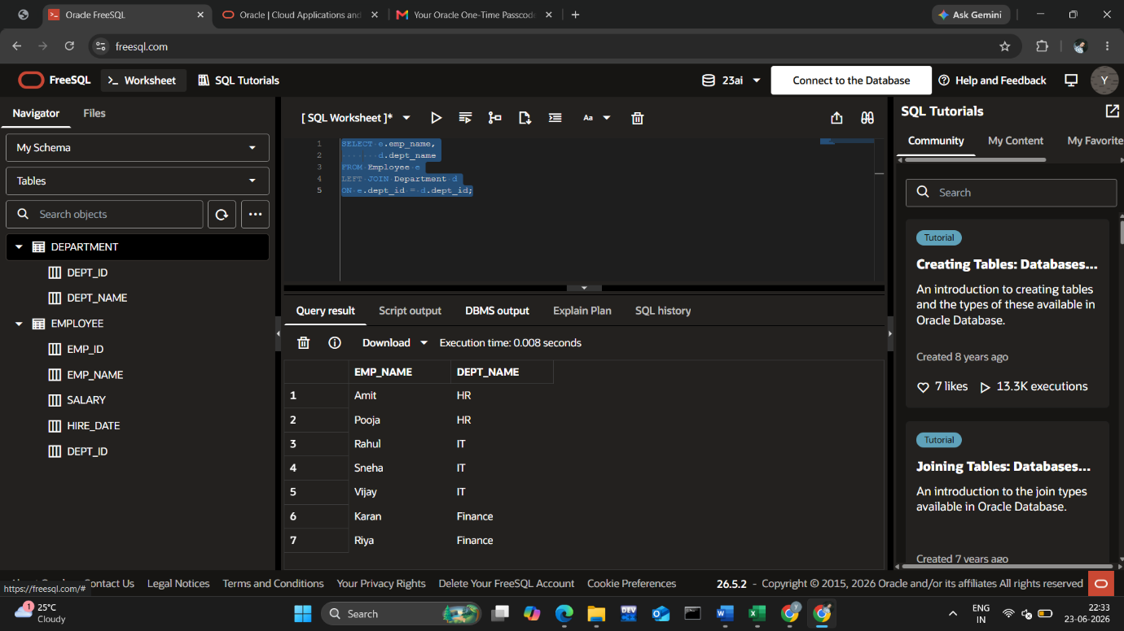

SELECT dept_id,
COUNT(*) emp_count
FROM Employee
GROUP BY dept_id
HAVING count(*) > 2;

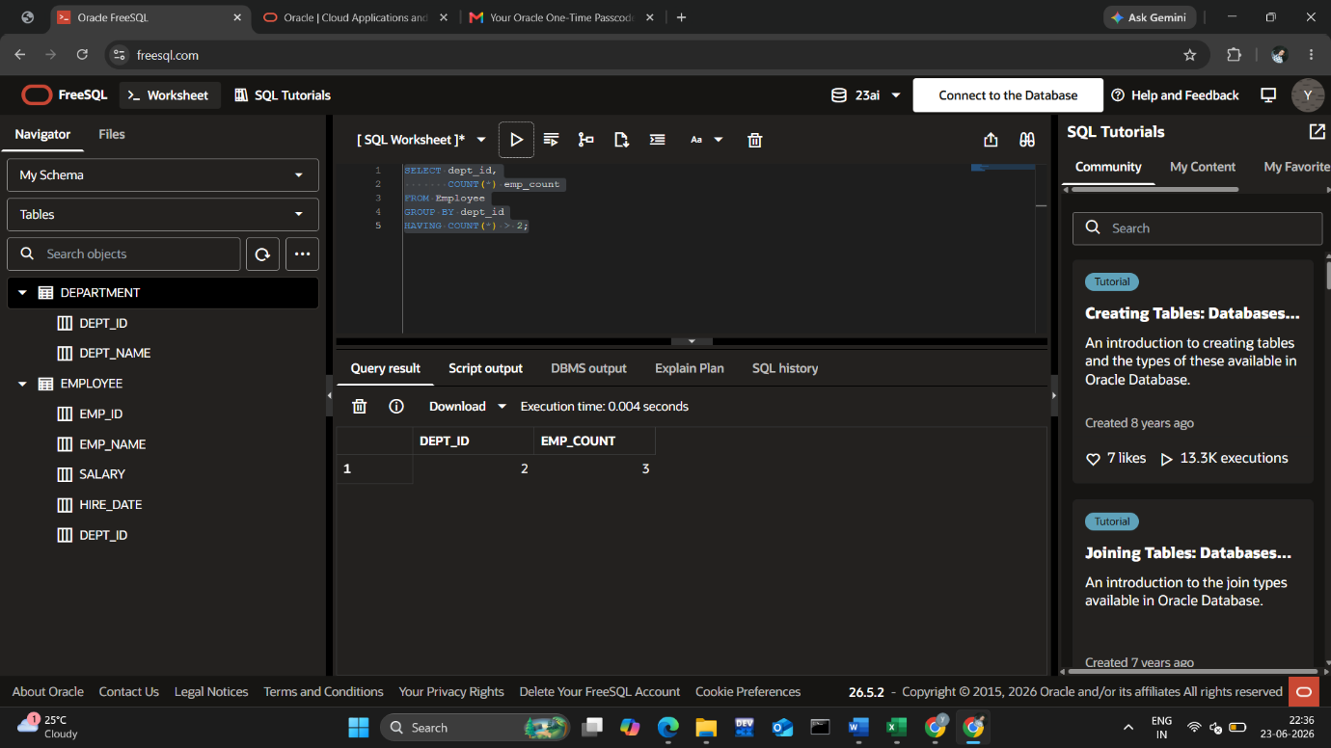

SELECT *
FROM Employee
WHERE hire_date >= ADD_MONTHS(SYSDATE,-6);

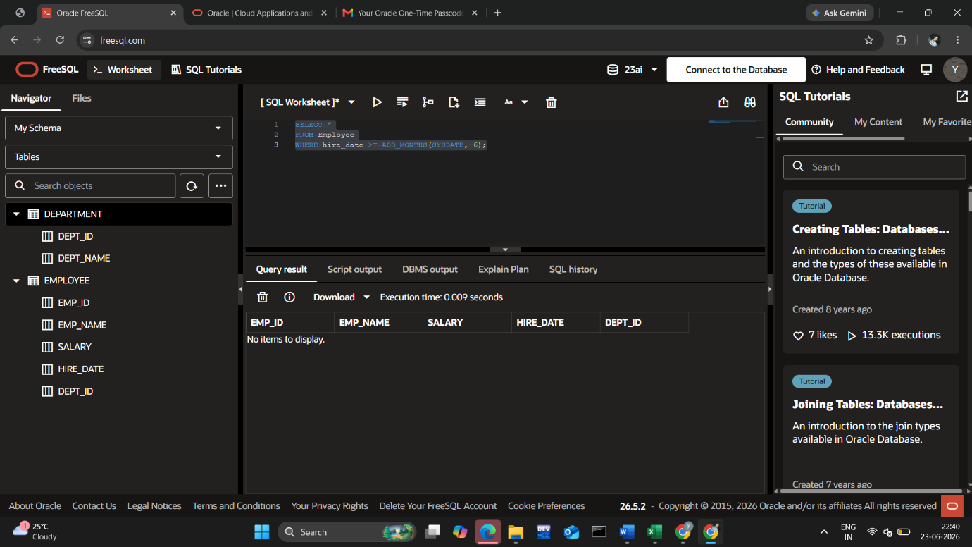

SELECT emp_name,
COUNT(*)
FROM Employee
GROUP BY emp_name
HAVING COUNT(*) > 1;
DELETE FROM Employee
WHERE ROWID NOT IN
(
SELECT MIN(ROWID)
FROM Employee
GROUP BY emp_name
);

